Accident Detection

This project is trained with images where vehicles collided and accident occurred and in test video if anything such collision happens between vehicles then application detect as accident. Training is done with tensorflow and CNN Algorithm.

To run project double click on run.bat file to get below screen

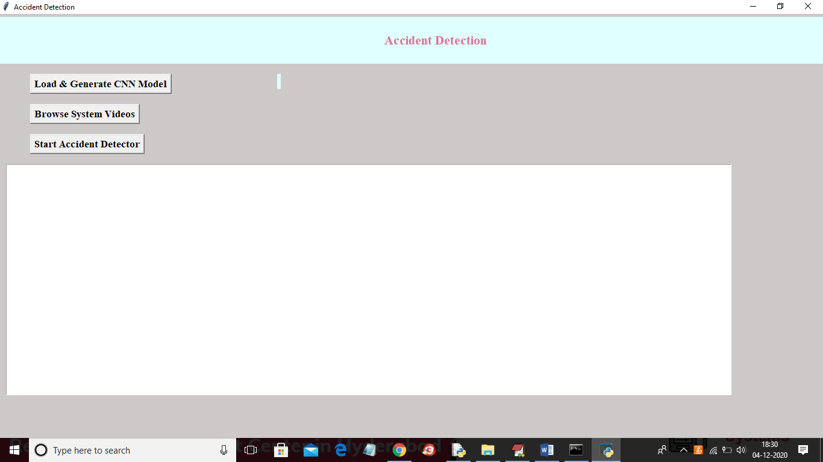

In above screen click on ‘Load & Generate CNN Model’ button to trained CNN with dataset and to load CNN model using tensorflow

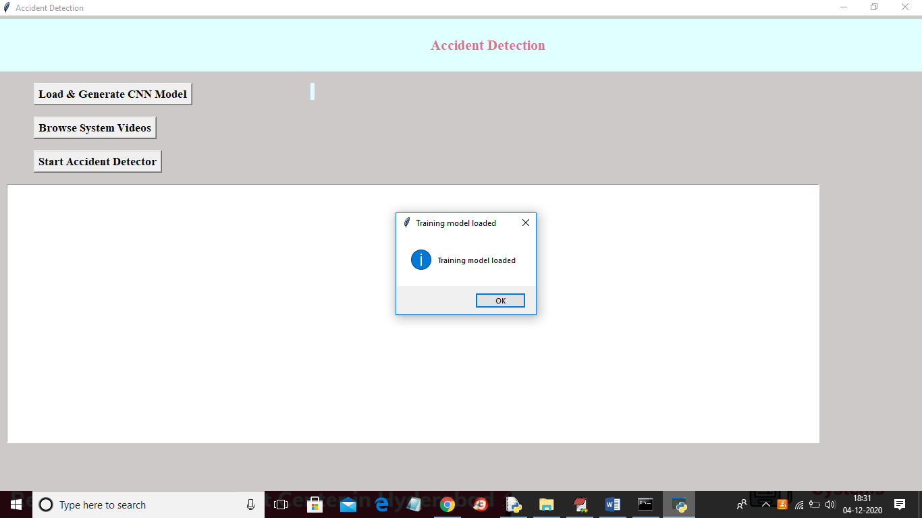

In above screen tensorflow model is loaded and now click on ‘Browse System Video’ button to upload video

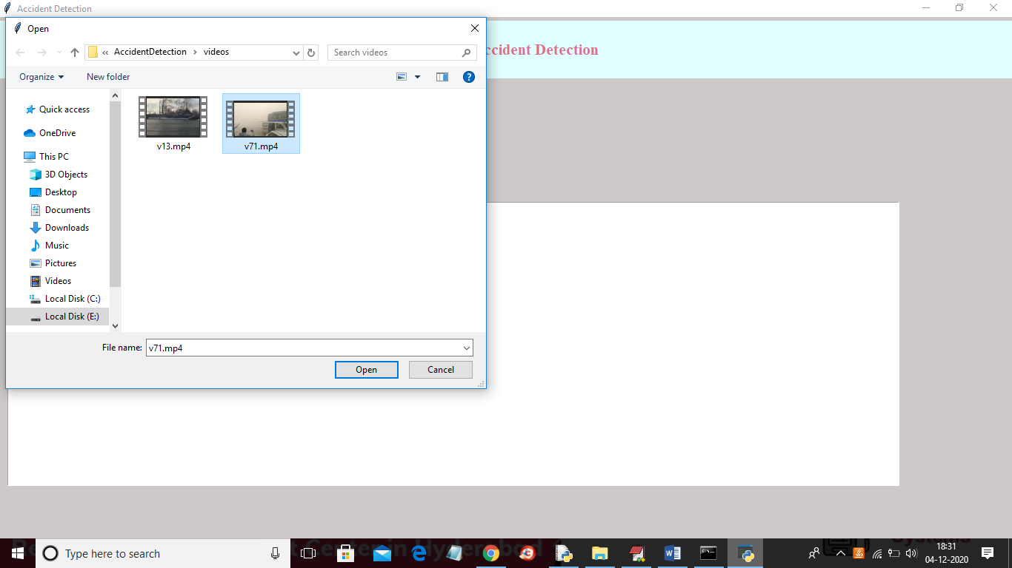

In above screen selecting and uploading video and then click on ‘Open’ button to load video

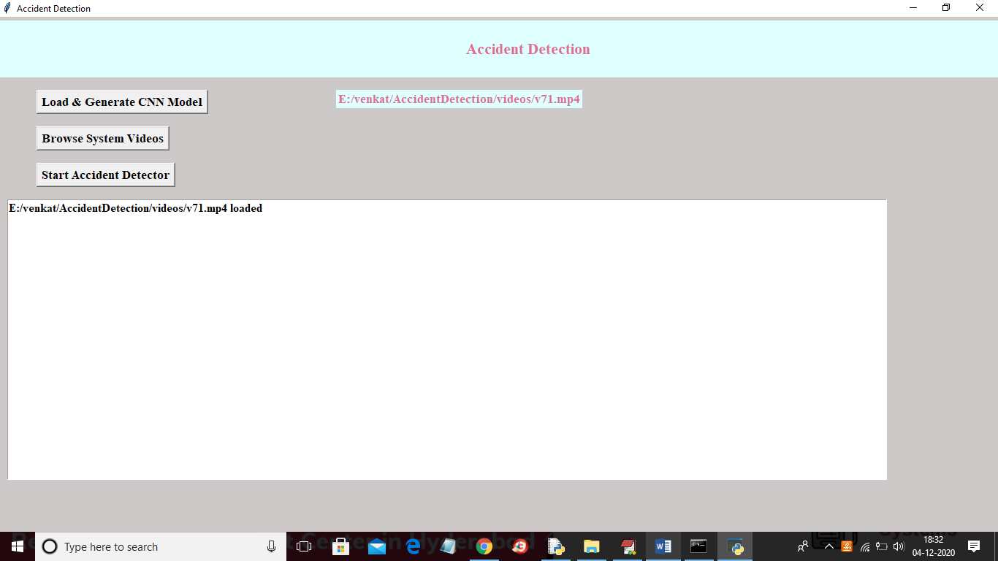

In above screen video is loaded and now click on ‘Start Accident Detector’ button to play video and detect accident

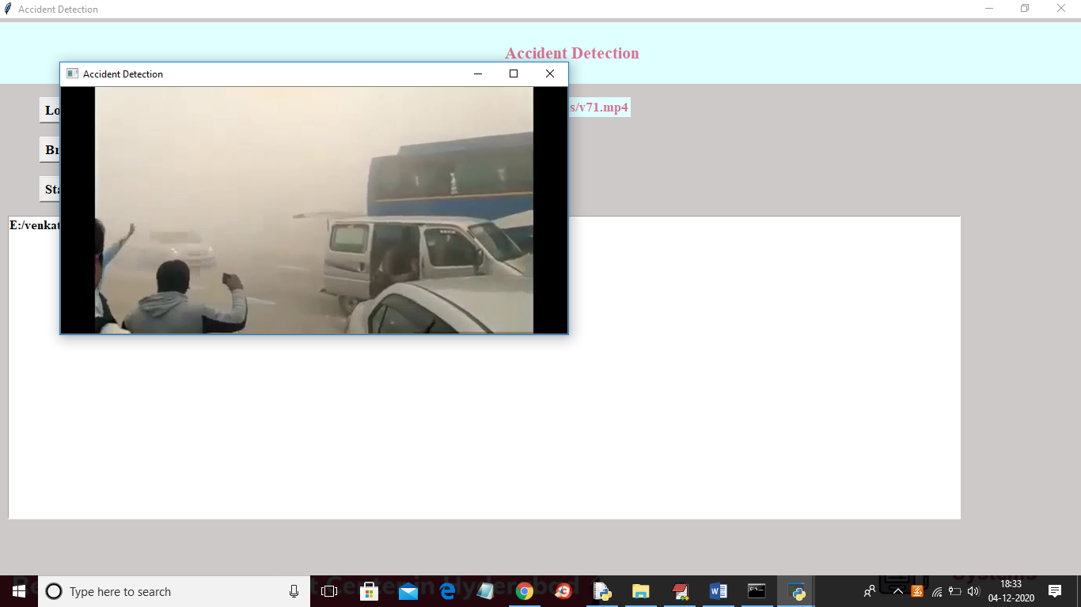

In above screen video start playing and upon accident detection will get below screen with beep sound

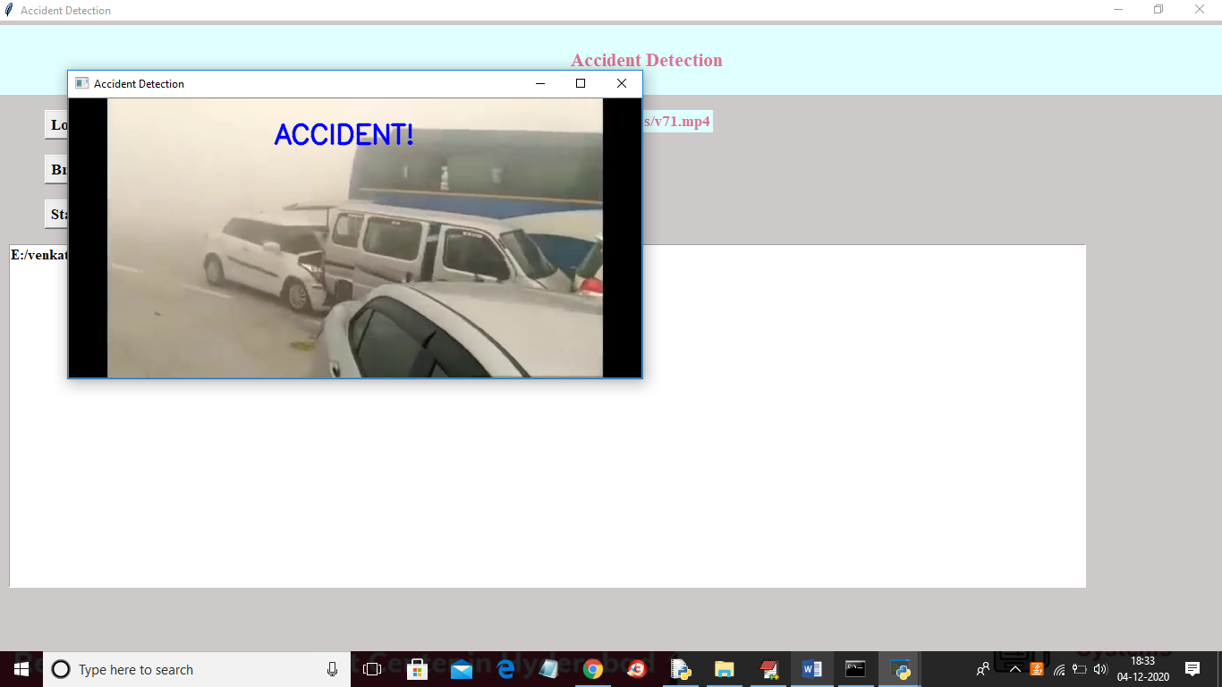

In below screen playing another video without message if normal driving appear

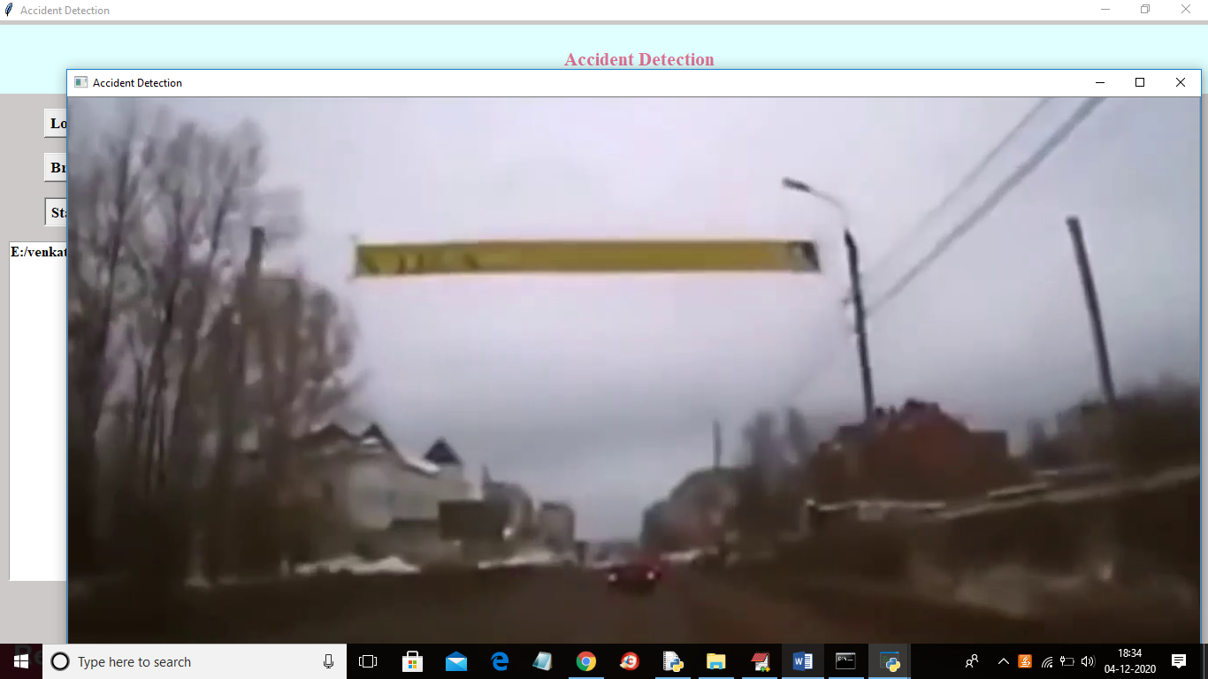

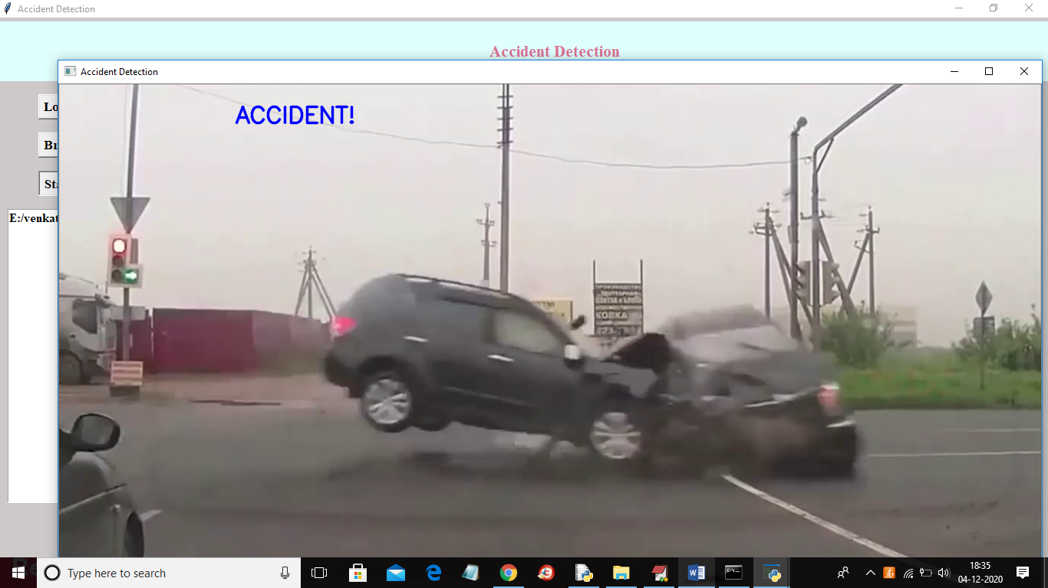

In above screen upon collision then accident display message will appear with beep sound

In below screen application is trained with below images

